**CS 557 Final Project**

**Magic Wall**

**CHI CHIEH WENG**

**wengchic@oregonstate.edu**

**Achievement display**

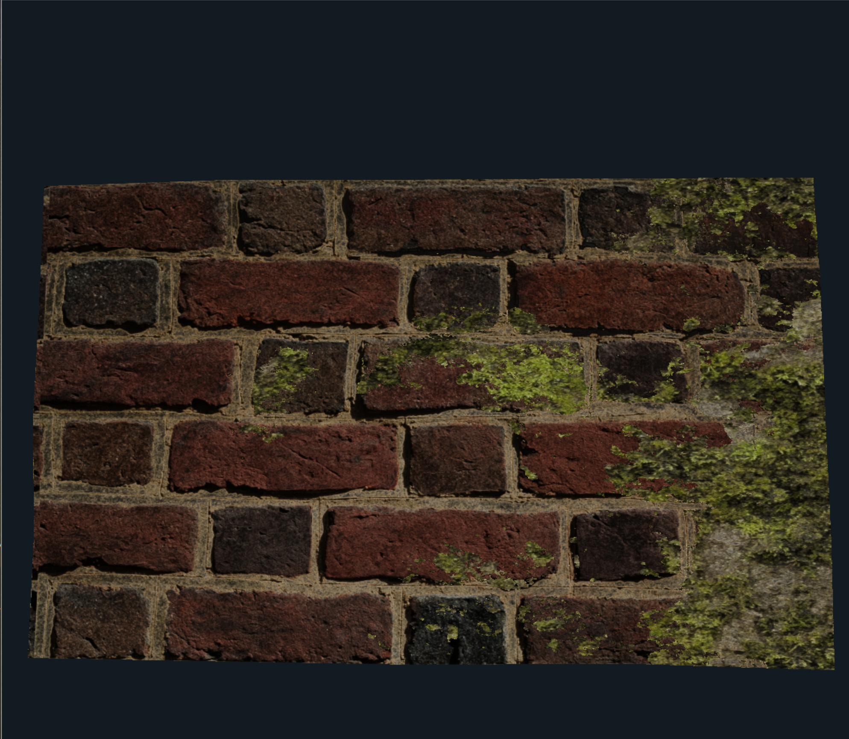

**Wave display**

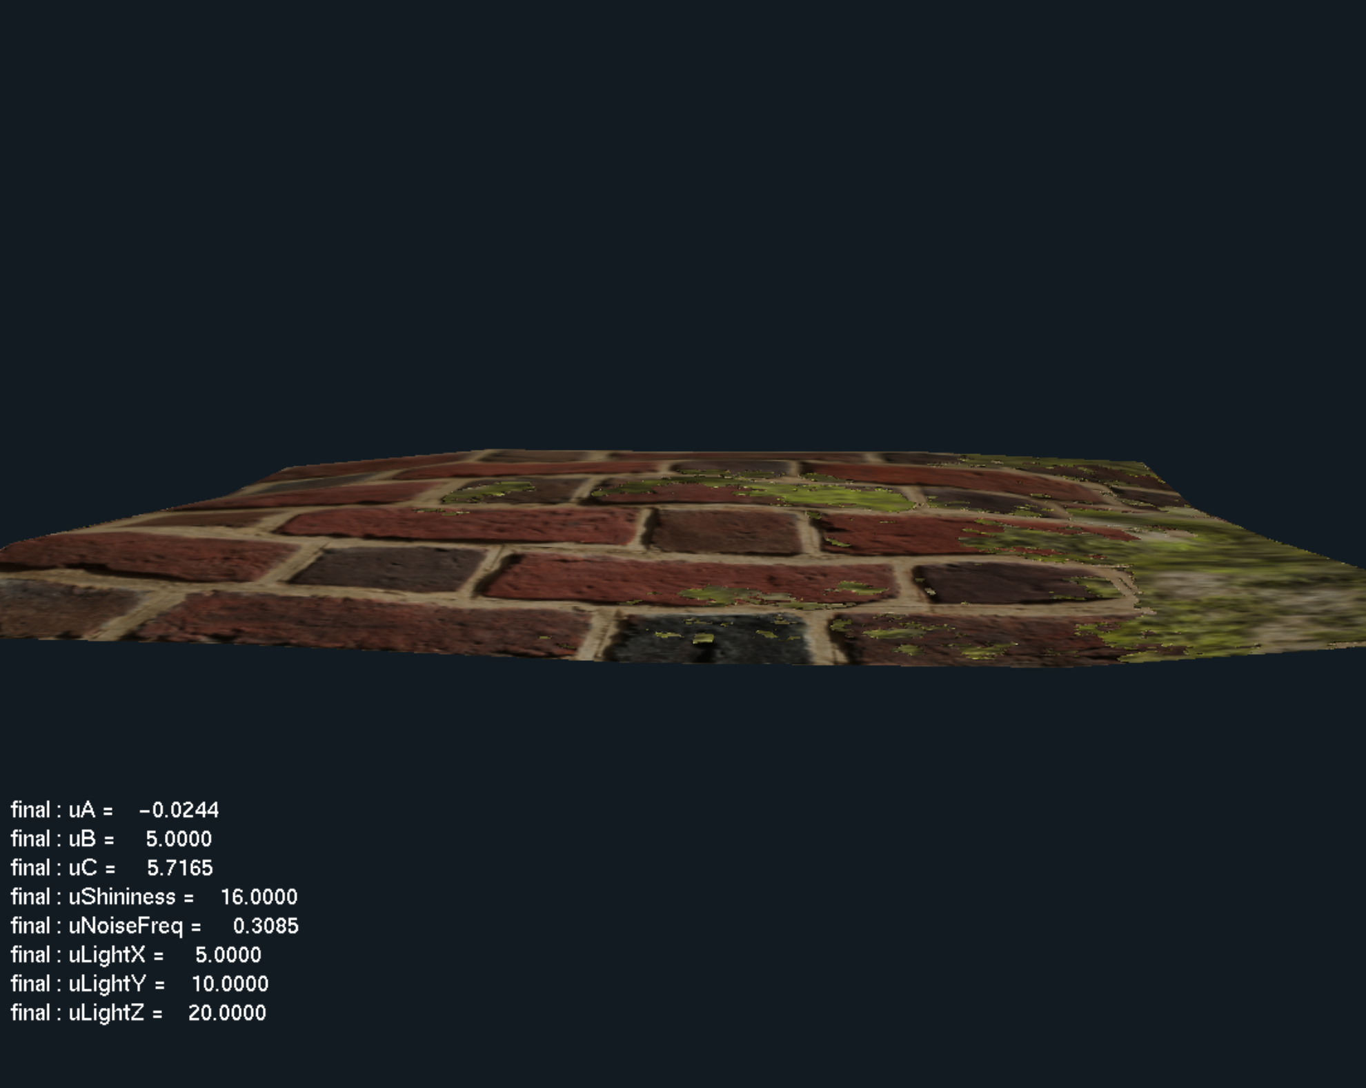

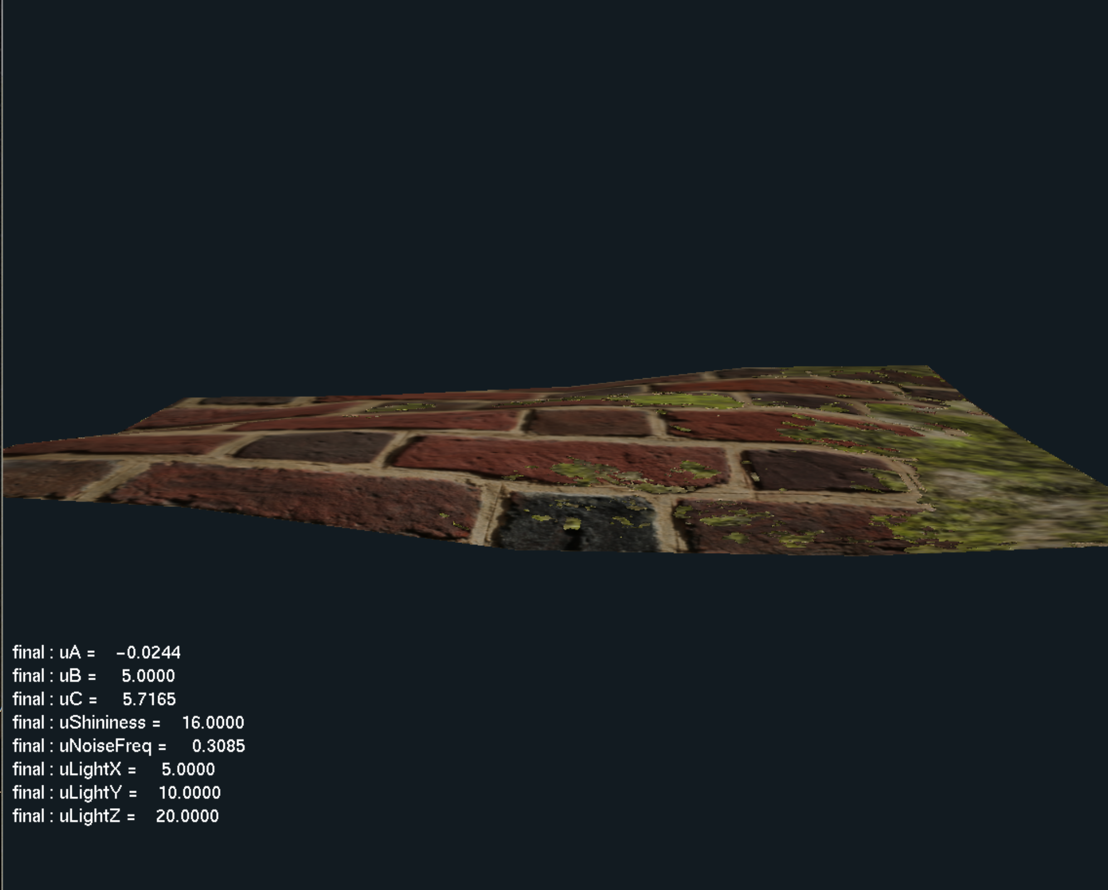

Use uA, uB, uC to change different waves to make the wall more like water waves. Also can use NoiseFrequency to adjust the frequency of the waves.

**Detail on the wall surface**

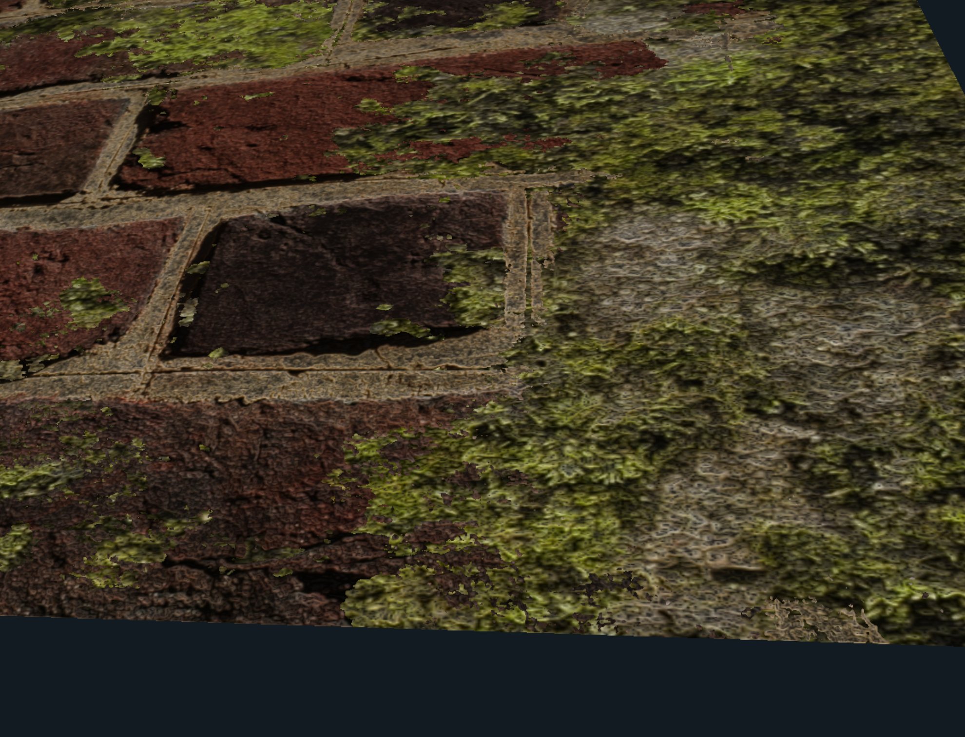

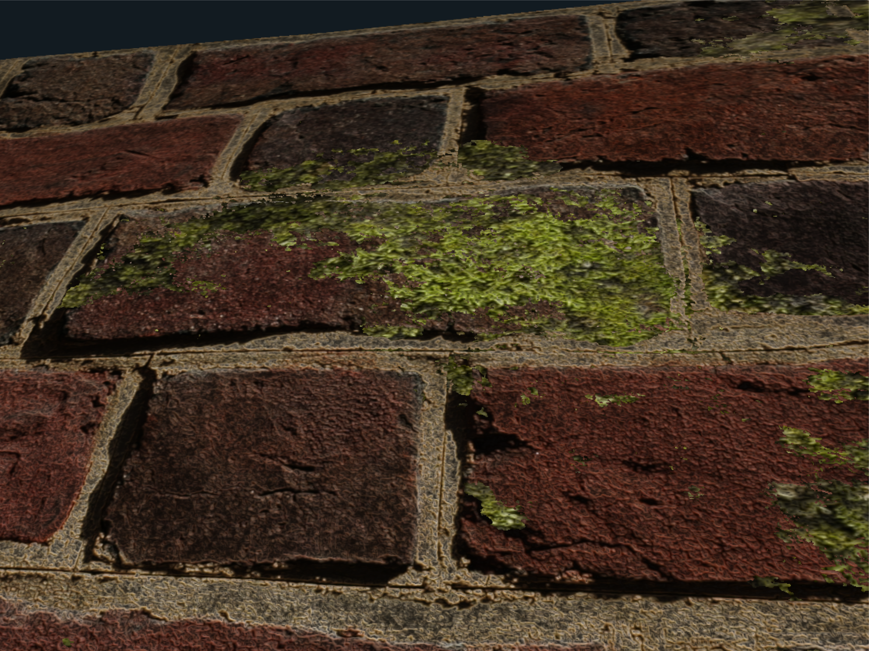

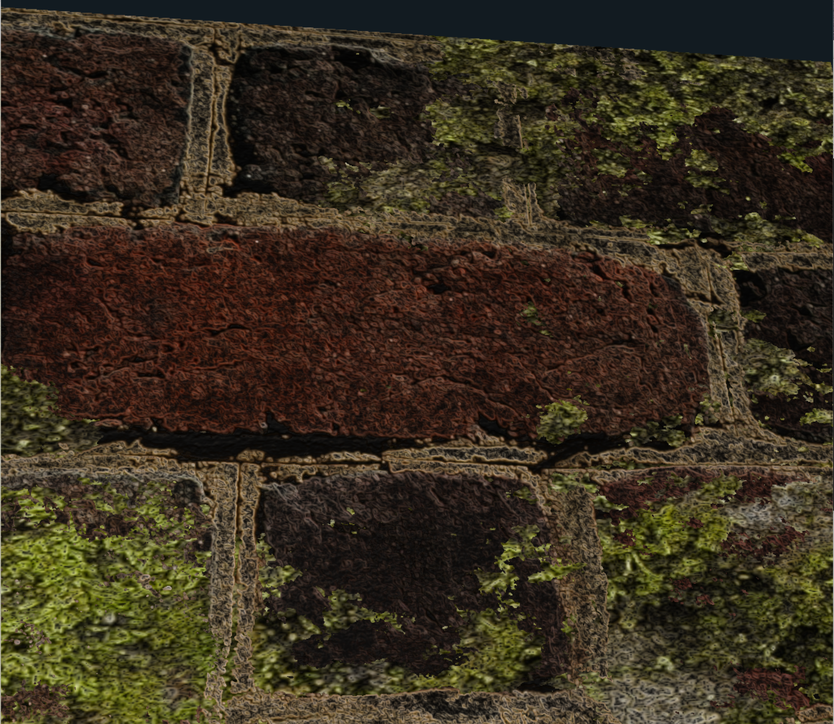

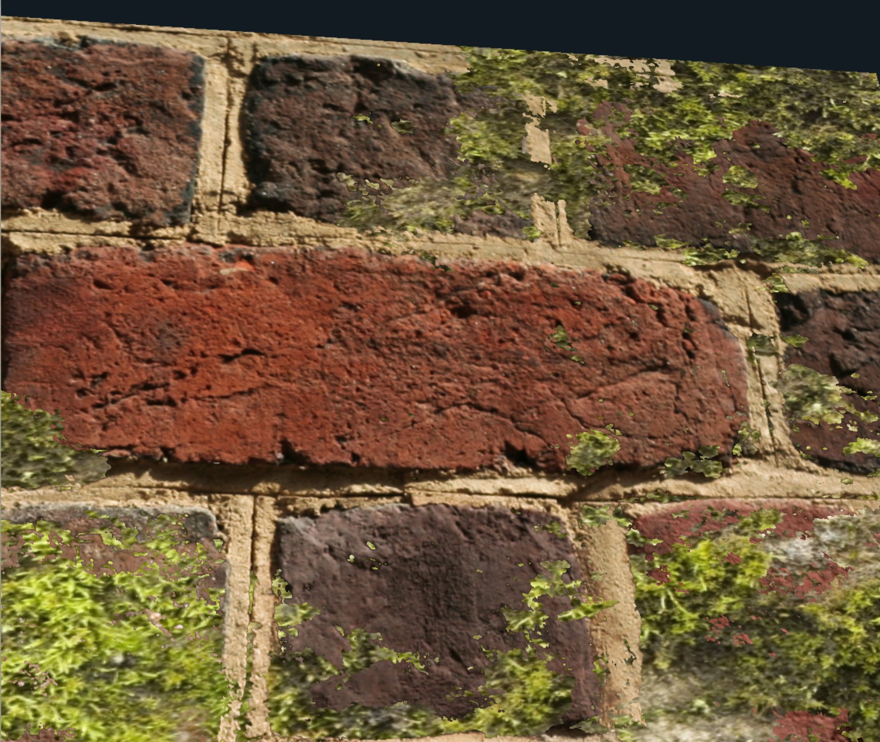

In this part, I mainly used two bmp files, brick and moss, to make the wall more realistic. Convert both files to Displacement textures, Normal-Mapping, Specular textures, and use a gradient map and a brick map to make them have different heights, then make them overlap each other, but make them not complete coverage. Finally, we can get moss on the bricks.

Video lnik: https://media.oregonstate.edu/media/t/1_eodxp0rf